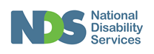
Standard 1 (Easy Read) template

What is safeguarding?

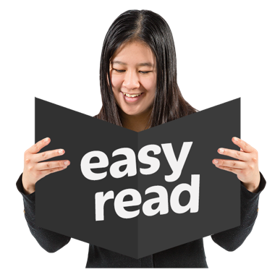

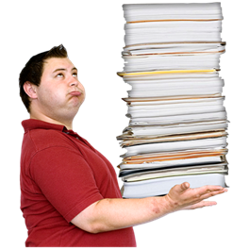

This information is written in an easy to read way.
We use pictures to explain some ideas.
Some words are written in bold. We explain what these words mean.

You can ask for help to read this information.

A family member, friend or support person may be able to help you.

Let us know if you need us to help you.

This Easy Read information is a shorter version of another document.

You can ask us for a copy of the longer document.

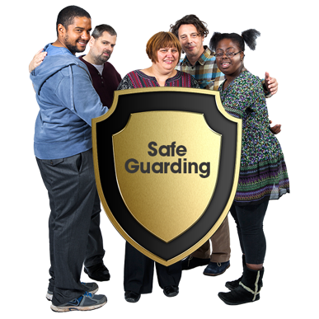

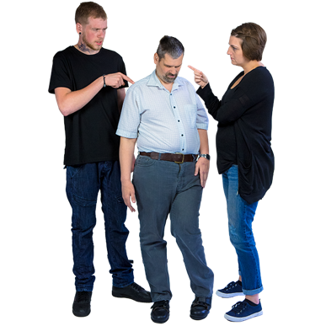

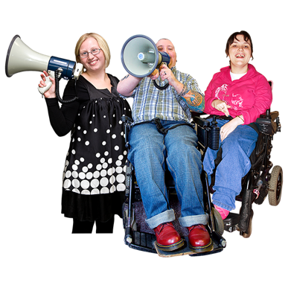

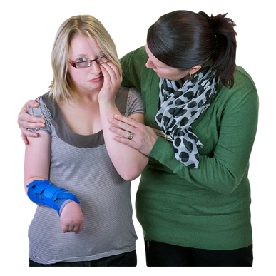

This document is about safeguarding.

A safeguard is a way of keeping people safe when they use services.

Safeguards help stop people from being hurt or treated badly.

Safeguards can help protect your rights.

No-one is allowed to hurt you.

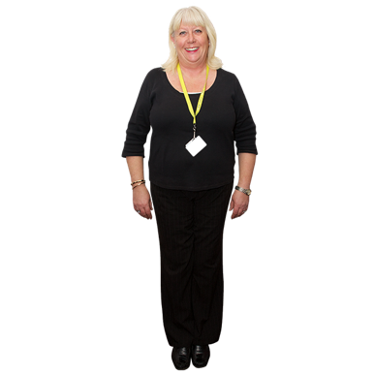

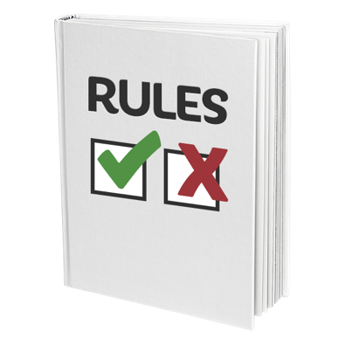

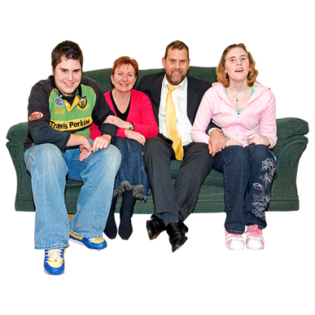

Here are some safeguards we use to help keep you safe.
We employ good staff

We train our staff how to support you

We have rules that all staff must use when they are supporting you

We support you to have relationships with people important to you

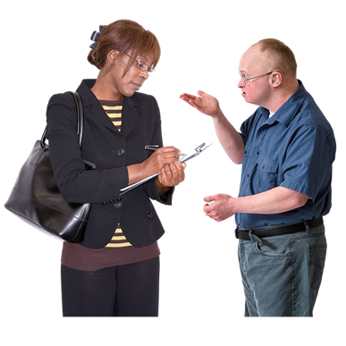

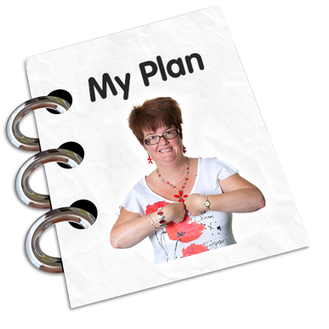

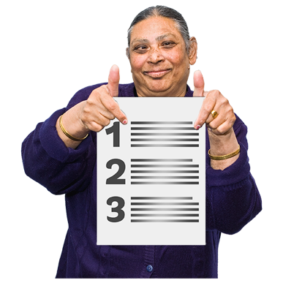

We give you information about what is ok and what is not ok

We support you to tell us if there is a problem
We make it easy for you or your family to complain

We will work with you to write a safeguarding plan if there are things in your life that could make you unsafe

A safeguarding plan has a list of ideas and things to do to help protect you and keep you well and safe

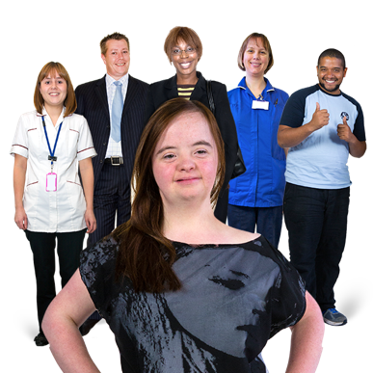
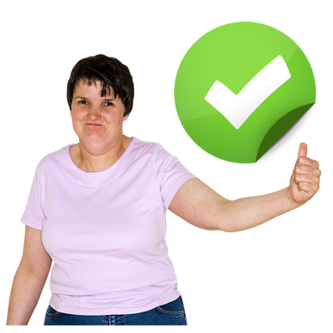

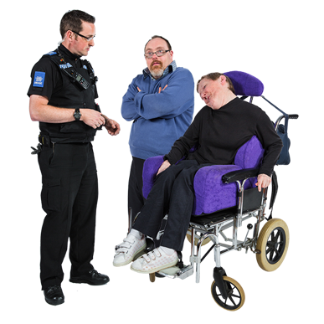

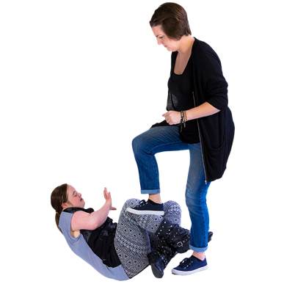

Everyone who works with you has to follow the plan

If something happens, we take quick action to try and fix a problem and make sure it doesn’t happen again

We follow the law and call police if we need to

Please tell us if someone hits you or hurts you

Please tell us if someone touches you in a way you don’t want to be touched

Please tell us if someone treats you badly or unfairly

Please tell us if someone takes your things or your money.

Please tell us if anything else worries you.
This is who to contact if you feel unsafe.
[Insert name/position/contact details here]

