Standard 6 (Easy Read) template

Consultation

This information is written in an easy to read way.
We use pictures to explain some ideas.

Some words are written in bold. We explain what these words mean.

You can ask for help to read this information.

A family member, friend or support person may be able to help you.

Let us know if you would like us to help you.

This Easy Read information is a shorter version of another document.

You can ask us for a copy of the longer document.

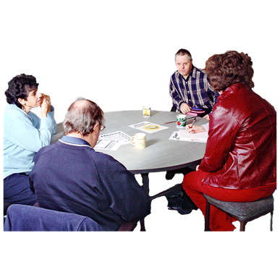

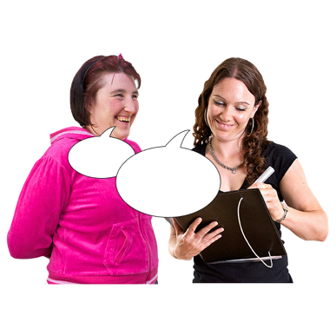

This information is about how we involve you in decisions about your services.

Consultation means we ask you to tell us about your experience and what you think.
- We might ask you about the best way to make a new service work.
- We might ask you about different types of new services.

We believe you know what is best for you. If you need support to make your own decisions, we can help you.

If you want us to, we can also ask your family or friends or other people what they think.

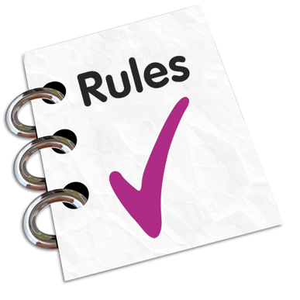

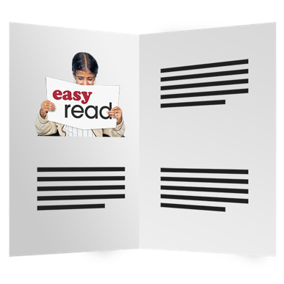

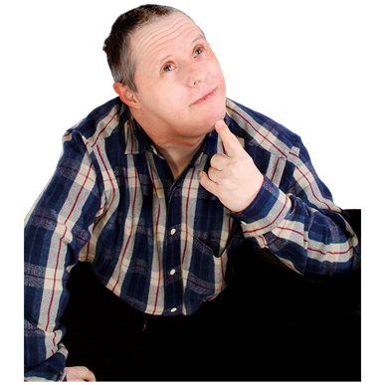

There are some rules we follow when we have a consultation.

We will give you information about the consultation.

We can give you the information in a document, or talk to you. We can also get it translated.

We will give you time to think about the information.

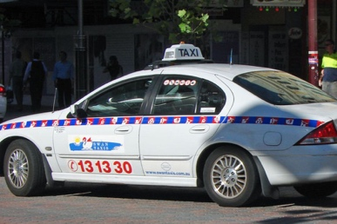

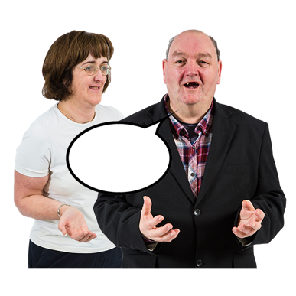
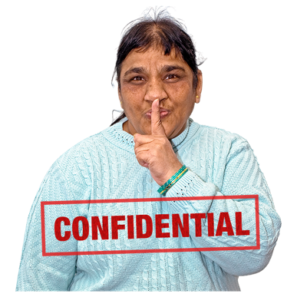

If we ask you to come to a meeting we will pay for you to get to the meeting. This could be paying for a bus or taxi.

It is ok to say what you think. We want you to have a say in decisions about you and your services.

We will keep what you say private.

We will tell you how we use your ideas.

Please contact [insert name, position and contact details] if you want to more information.

